Review Questionnaire
In preparation for your next appointment,
please complete online and email back prior to your visit if you can.

Name : | Date : | Appointment # :
What has changed / happened since your last appointment? What are you noticing (be specific)?

What percentage improvement have you noticed overall? (0=none - 100% vast improvement)

What percentage have you been on your dietary regime? (0=not - 100% strictly on it)

What percentage have you been on your supplement regime?
(0=not - 100% strictly on it)

Have you or are you seeing any other practitioners since your last visit? (If so, who & what for?)

Have you stopped or started any supplements or medications?

What supplements are you taking presently?

What is your focus for your next appointment?

What is your end goal?

What is obstructing or preventing this?

What has been successful in your treatment so far, what are the positives?

What has not been successful yet, what are the negatives?

Have you had any shocks, traumas, injuries or impacts to your body or emotions since your last appointment?
How are you feeling emotionally compared to your first vist?

Medical Update - are there any medications you have started or stopped, or any medical appointments you have attended?
Have you seen any other health care professionals, started or stopped any supplements, herbs or other Natural remedies?
How many Neurofen, Panodol, Antibiotics or other over the counter medicines have you used since your last appointment?
What exercise are you doing & how much?
Rate the intensity MILD/MODERATE/HIGH

Please rate out of 10 0 = nil / 10 = high | 0-10 | Comments
Energy levels
Stress
Anxiety
Low Mood
Irritability
Teariness
Frustration
Sleep quality
Average hours of sleep
Number of times you wake |  | What time/s do you wake?  Time taken to go back to sleep -
Mental Clarity / memory
Bowel function overall (well formed & easy to pass / loose / diarrhoea / lots of wind / mucus / constipated / other |  | How often are you having a bowel motion?  A number of times a day / daily / every other day / weekly / other :
Do you have Haemorrhoids?
Bloating
Wind / flatulence. Is it Odorous?
Skin
Night sweats
Sense of Wellbeing
Rate your diet
Weight
Sugar cravings
Libido
Headaches / Migraine
WOMEN :- | …/10
Period pain
Breast Tenderness |  | 1ST day of last period – date :
Fluid retention
Flushing / sweating (day / night)
How long was your last cycle (first day of period to day before flow of next period)
PMS (0=none 10= severe)
BODY PAIN / DISCOMFORT : Please rate where 1 = low / 10 = high.
Muscle tension / hardness / knots |  | How is your body feeling?  Mark any areas of discomfort or issue.  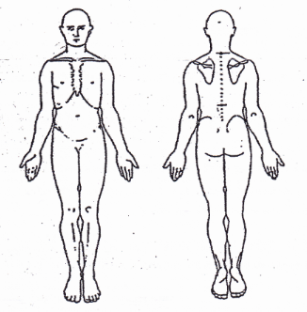
Body pain
Headaches
- intensity
Neck & Upper Shoulders
Lower Back
Legs
Arms & shoulders
Joints
Legs & feet
Is there anything else that you would like to add?

