NAME: | DATE OF BIRTH & AGE :
EMAIL ADDRESS : | PHONE NUMBER :
How did you hear about Reconnective Healing / who referred you? | MEDICATIONS / SUPPLEMENTS :

WHAT IS GOING ON FOR YOU RIGHT NOW?

WHAT ARE YOU HOPING FOR BY HAVING A RECONNECTIVE HEALING SESSION?

WHAT ARE YOUR EXPECTATIONS?

WHAT DO YOU KNOW ABOUT IT?

RATE EACH AREA OF YOUR LIFE OUT OF 10, where 10 is completely satisified.
Rate | WHEEL OF LIFE | 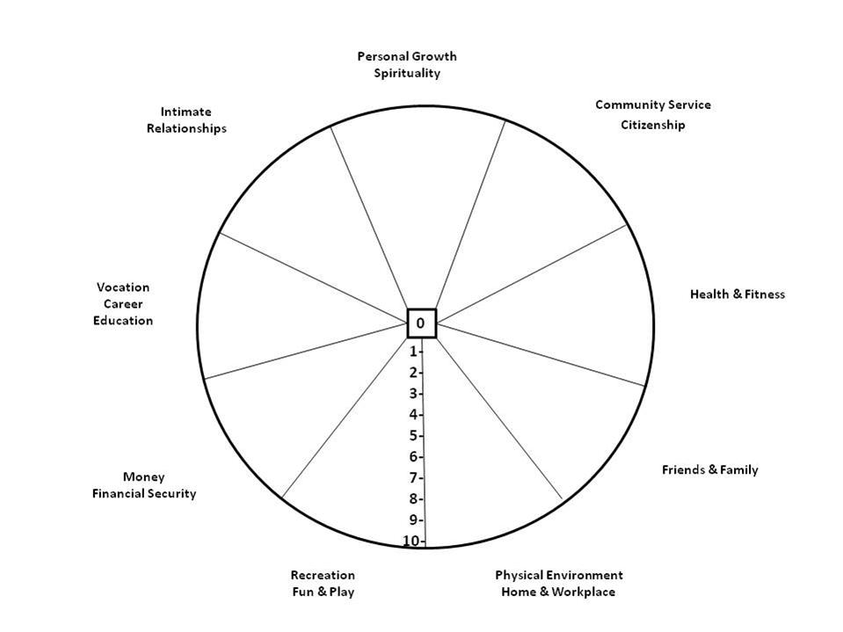
 | Personal Growth & Spirituality
 | Community, Service, Citizenship, Sharing in a community sense.
 | Health
 | Fitness
 | Friends
 | Family
 | Physical Environment - Workplace / School
 | Physical Environment – Home / Living zone
 | Recreation, Fun, Play
 | Money, Financial Security
 | Vocation, career, education
 | Intimate relationships
 | Sense of Self, confidence, personal respect
 | Other area/s of importance to you :

What are your spiritual beliefs?
YES/NO
Do you believe you have Past Lives?
Do you believe in Life between lives, the place where the soul is said to reside between lifetimes?
Are you religious in the traditional sense?
Are you spiritual in the non-traditional sense?
Are you open to past life regression?
What do you believe in?

Is there anything else we need to know?

Please read, sign and return before your session :
Session Information - It is important to understand that this session is not intended to diagnose or treat any medical, mental or physical condition. This session is simply an infusion of the Reconnective Healing energies for your body to utilise in its innate wisdom. We offer no promises or claims about what will happen during or after your session. We do not intend or promise any medically therapeutic results, as we cannot gauge how your body will use this energy. Consider this session to be similar to a meditation that you are engaging in during the time you are on the table.
Most people feel the sensations of tingling, warmth, pressure, twitching and more, some people don’t feel anything other than a lovely feeling of relaxation. To understand this energy, it is important that you have watched the videos located on the website under Reconnective Healing. By signing this form you are acknowledging that you have watched these programmes and are responsible for asking any questions before your session.
It is best to have no expectations, no judgements, no preconceived ideas and no agenda when you receive this session. If you are holding on to any of these you will set yourself up for disappointment. Only when you truly let go of the mind, will you find your own insights. Holding on to an expectation outside of this will confound your experience. Open your heart and open your mind, be in a state of reception, and let go of everything else. Notice what you notice, but don’t hold on to anything.
DISCLAIMER - This disclaimer should be read in its entirety. The information available through Monica Williams or www.healthierbychoice.com.au is not a substitute for independent and personal professional medical advice. This site contains information, data, documents, policies, procedures, guidelines, images and general material prepared to make available information that may better inform the community. In particular, the linked information and reference materials are intended solely for the information of the user. We do not accept liability for any injury, loss or damage incurred by use of or reliance on the information.
Information Subject to Change - Any information given or on the web site may include technical inaccuracies or typographical errors, and the information may change from time to time without notice. Whilst the information is considered to be true and correct at the date of publication, changes in circumstances after the time of publication may impact the accuracy of the information. The Foundation is not and will not be, in any way, liable for the accuracy of any information printed and stored or in any way interpreted and used by a user.

No Warranties - To the extent permitted by law, this web site and the information and services provided by us, are provided in an "as is", "as available" basis without warranties of any kind, express or implied, including, but not limited to, those of title, merchantability, fitness for a particular purpose or non-infringement or any warranty arising from a course of dealing, usage, or trade practice. No oral advice or written information provided by Monica Williams, Healthier By Choice or its employees, shall create a warranty; nor should visitors to the site rely on any such information or advice.

Disclaimer of Liability - The user assumes all responsibility and risk for the use of this web site, information and services provided. Under no circumstances, including negligence, shall Monica Williams, Healthier By Choice or its employees or anyone else involved in creating or maintaining this web site be liable for any direct, indirect, incidental, special or consequential damages, lost profits, revenue, data, goodwill, business opportunity or bargain, that results from the use or inability to use the web site and/or any other web sites which are linked to this site, or the information and services provided on the web site. Nor shall Healthier By Choice or its employees be liable for any such damages including, but not limited to, reliance by a visitor on any information obtained via the web site; or that result from mistakes, omissions, interruptions, deletion of files, viruses, errors, defects, or any failure of performance, communications failure, theft, destruction or unauthorised access. In areas which do not allow some or all of the above limitations of liability, liability shall be limited to the greatest extent allowed by law.

Disclaimer of Endorsement - Reference to any products, services, hypertext link to the third parties or other information by trade name, trade mark, supplier or otherwise does not constitute or imply its endorsement, sponsorship or recommendation. Nor is an endorsement of The Foundation or its employees implied by such links.

Link Disclaimer - These links are provided simply for convenience, we take no responsibility for the accuracy, currency, reliability and correctness of information, links or references to information sources (including Internet sites) outside of this site. Views or recommendations provided in linked sites do not necessarily reflect those of Healthier By Choice. It is the responsibility of the users to make their own investigations, decisions, and enquiries about the information retrieved from this or other Internet sites.
Date : Name : Sign :

